GDPR Detailed Assessment for Partners

**Datasheet**



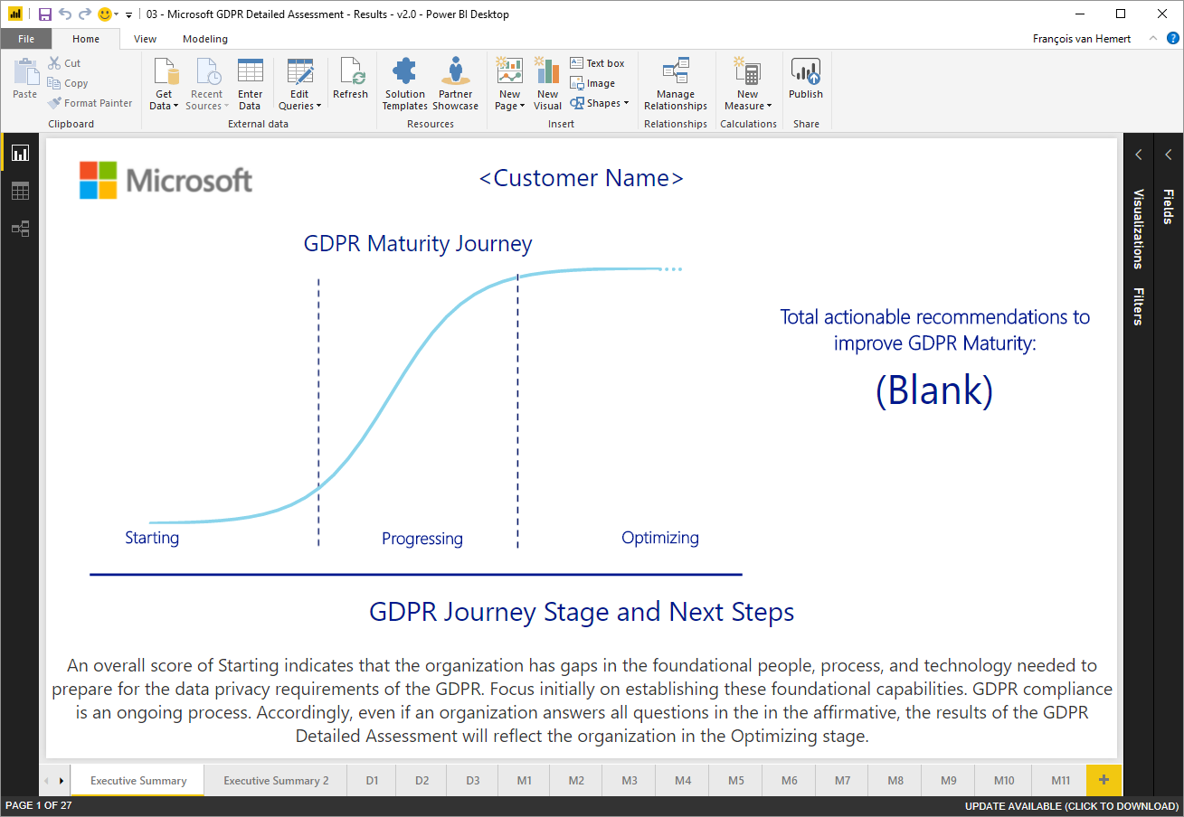**What is the GDPR Detailed Assessment?**

A tool that partners can use to help customers assess the maturity of their people, processes, and technology, relevant to the GDPR. A tool that provides visuals and recommendations to guide customers to appropriate solutions, enabling customers to elevate their GDPR maturity.

*Note:* *The Microsoft GDPR Detailed Assessment is NOT a tool to certify compliance. It is the distributed responsibility of the customer and their legal and compliance teams to certify their own GDPR compliance.*

**What is the partner opportunity?**

This assessment toolkit is designed as an example and template to help partners quickly go to market to deliver profitable engagements, solutions, and a managed lifecycle of services assisting customers on their journey towards GDPR compliance through gap analysis and identification of potential data security and compliance challenges. Using the assessment toolkit, they can quickly develop pipeline and grow their trusted advisor status with the customer.

*IMPORTANT! This toolkit must be customized by the partner so that it aligns to their value proposition, workflows, delivery methodologies, etc.*

**What are the customer opportunities?**

Understand customer GDPR compliance objectives

Gain a common understanding of compliance objectives and GDPR requirements



Assess customer GDPR maturity level

Assess customer’s preparedness to execute on Discover, Manage, Protect and Report activities.



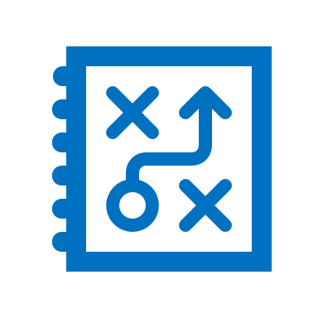

Create a GDPR compliance roadmap

Provide a prioritized and actionable list of next steps and roadmap, ready for legal/advisory review.

**What’s included with the GDPR Detailed Assessment toolkit?**

The following partner assets are available for download and ready for partner customization:

* 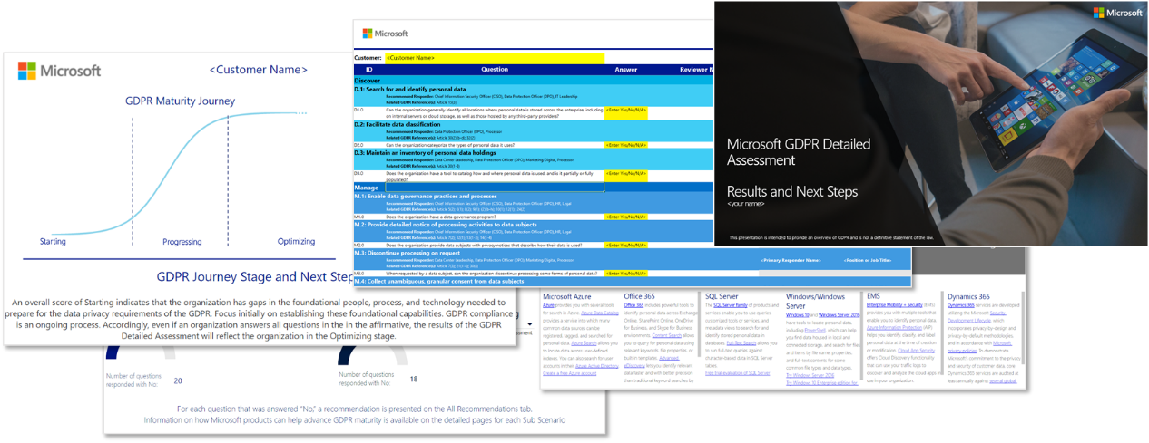Engagement delivery guide
* Pre-engagement Presentation
* Example SOW
* Kick off presentation
* Input Tool
* Results Tool
* Close-out presentation
* How to deliver guide

**How can Microsoft help?**

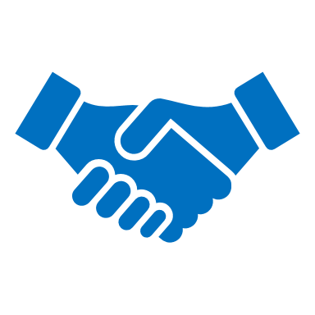The One Commercial Partner Security Technical Team (OCPSTT) within Microsoft can provide security expertise and architectural support in solution offering development, practice development, and technical enablement. We can support GTM strategy, marketing support, and sell-with support for your security solution offerings. Examples include sales and technical training for your practice, proof-of-concept support, customer briefing co-delivery, and more to demonstrate the partnership between Microsoft and your organization. Partners can contact their Partner Development Manager (PDM) to engage with the OCPSTT.

**Training Program:**

The OCPSTT offers a complimentary training curriculum to help partners succeed in the delivery of the GDPR Detailed Assessment, including driving value as their trusted advisor using the roadmap and strategy that was developed as an outcome from the engagement. The following course syllabus and agenda outlines the training sessions offered:

|  |  |  |
| --- | --- | --- |
| **Time** | **Session Name** | **Abstract** |
| 7:45-8:00am | **Welcome (Breakfast)** | |
| 8:00-9:00am | What is the GDPR and the assessment? | * Overview of the GDPR * What is the GDPR Detailed Assessment and how to use it * Pre-assessment questionnaire * Planning and preparing for the engagement   + Partner project team   + Customer project stakeholders   + Project scope   + Requirements and key decisions   + Partner and Customer technical resources   + Roles & Responsibilities * Deliverables and work products * Tools required * Assessment requirements |
| 9:00-9:30am | Pre-engagement meeting | * Introduce the engagement and the tools that will be used; * Align expectations; * Decide on the starting date for the on-site activities and define timelines; * Determine the appropriate customer responders that will be interviewed during the assessment |
| 9:30-9:45am | **Break** | |
| 9:45-11:00am | Assessment | * Conducting the kick-off meeting * Starting the GDPR detailed assessment * Conducting interviews * How to answer questions |
| 11:00-12:00pm | Outcome Analysis, Write Up & Closeout | * Extract results to PowerBI * Write executive summary, recommendations and roadmap * Best practices for delivering the close-out presentation * How to inform the customer on the outcome of the assessment * Recommended technologies and services the customer can leverage * Roadmap with actionable items and timeline |
|  | **Wrap Up** | |